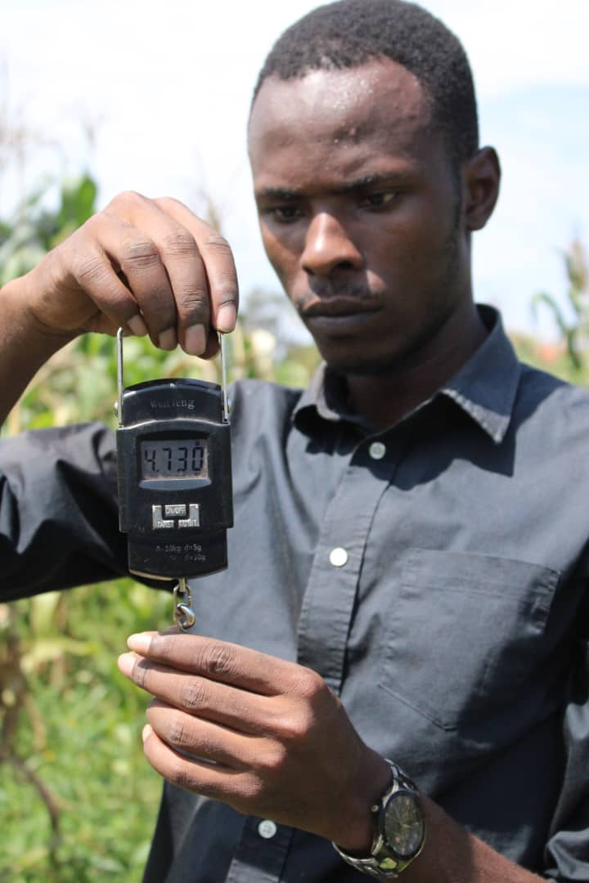**Predicting Rainfall to Boost Yields: Kyambogo Student Tests New Agricultural Tool**

In a groundbreaking move to tackle Uganda's erratic rainfall patterns, a Kyambogo University student uses cutting-edge technology to enhance agricultural productivity. Bylon Mushemeza, currently pursuing a master’s degree in Crop Science, is leveraging the Seasonal Characteristics Tool (SCT) to predict rainfall onset and improve maize planting schedules. This innovation is set to revolutionize farming practices in Uganda, where unpredictable weather patterns threaten food security.

The SCT, developed by Napoleon Katambira, a software developer at the National Agricultural Research Laboratories (NARL) under the USAID-funded ERAAL project, utilizes advanced forecasting methods to tackle the longstanding issue of rainfall unpredictability. The tool employs two forecasting approaches: the analog method, which compares the Long-Term Mean with data from analog years provided by the Department of Meteorology, and the historical data method, which draws from over 60 years of climate records. These methods allow farmers to make informed decisions about when to plant, significantly reducing the risks associated with late or early planting.

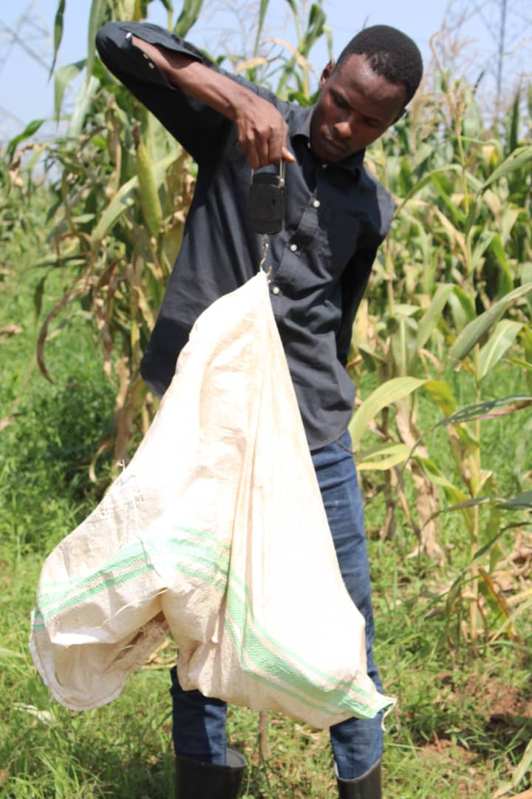Bylon Mushemeza is at the forefront of testing this tool in real-time agricultural scenarios. His research involves planting maize synchronizing with the SCT’s rainfall predictions to determine its accuracy and reliability. “The Seasonal Characteristics Tool is a game-changer,” Mushemeza asserts. “With the unpredictability of rainfall, farmers have struggled to get their timing right, often resulting in poor yields. This tool can solve that problem by providing precise forecasts, allowing us to plant at the most optimal time.”

Mushemeza’s research is part of a broader effort by the ERAAL project to build capacity in agricultural research and innovation. His tuition is fully funded by the project, demonstrating ERAAL's commitment to nurturing future agricultural scientists who will drive Uganda’s resilience to climate change.

The maize crop planted under Mushemeza’s SCT-guided schedule has shown promising signs from germination through to harvest. If the final results meet expectations, it will provide a compelling case for scaling up the tool’s use across Uganda.

Katambira, the brain behind the SCT, highlights the urgency of adopting digital tools to mitigate climate risks. “Farmers have long relied on traditional knowledge and guesswork to predict weather patterns, but climate change has rendered these methods unreliable. The SCT provides scientific accuracy, making agriculture more resilient and profitable,” he explains.

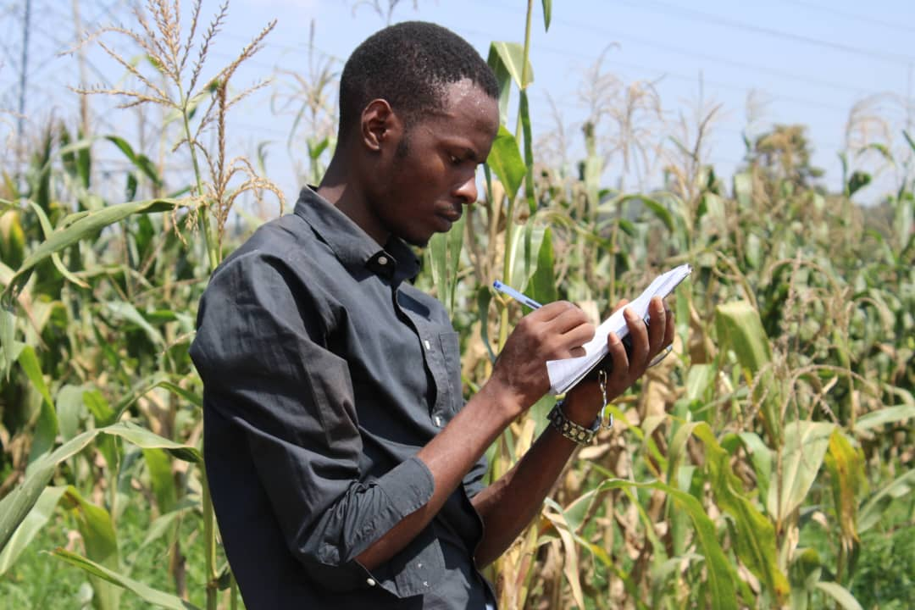The unpredictability of rainfall onset and cessation has long been a stumbling block for Uganda’s farmers, many of whom depend on rain-fed agriculture. Late or premature planting due to incorrect predictions can result in significant losses. The SCT aims to address this challenge by providing farmers with timely, accurate data to make informed decisions, thereby reducing crop failure and enhancing food security.

Mushemeza’s maize field, meticulously monitored from germination to harvest, will serve as a test case for the SCT's efficacy. His findings will inform future enhancements to the tool and contribute to its potential nationwide rollout. “Once farmers see the tangible benefits of using SCT to improve their yields, adoption will be swift. It could revolutionize agriculture in Uganda,” Mushemeza adds.

The ERAAL project, which focuses on scaling up climate-smart agricultural practices, sees the SCT as a critical component in building resilience against climate variability. Uganda’s agricultural sector, which employs over 70% of the population, must adapt to these changing conditions to ensure food security and sustainable livelihoods.

As Mushemeza prepares to conclude his research, the agricultural community eagerly awaits the results. The stakes are high. If successful, the SCT could become a vital tool in Uganda’s agricultural arsenal, empowering farmers to combat climate risks and maximize their yields.

For now, all eyes are on Mushemeza’s maize field, a beacon of hope for farmers grappling with the effects of climate change. The clock is ticking, and the need for reliable forecasting tools has never been more urgent.