Agrometeorology Team Validates Seasonal Information to Strengthen Early Warning for Farmers
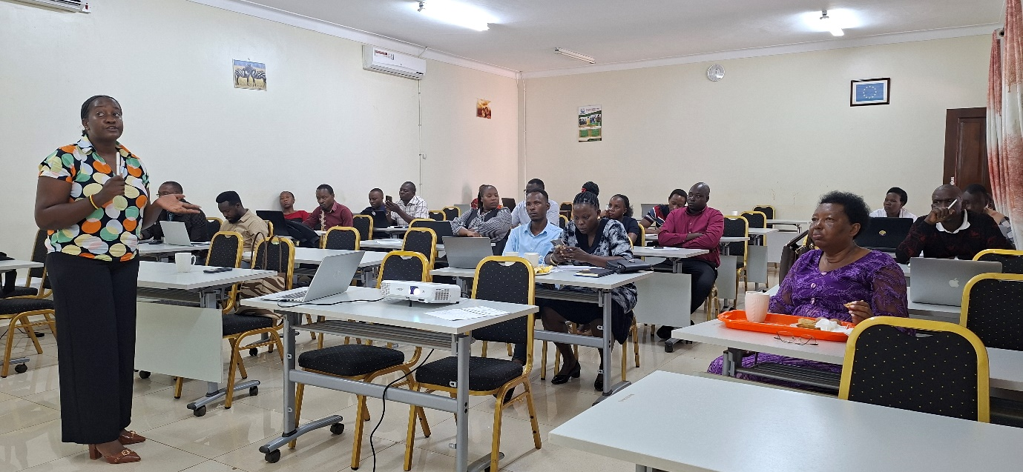Kawanda, Uganda | 11 August 2026 — The Agrometeorology Team under the Uganda Climate Smart Agricultural Transformation Project (UCSATP) is conducting a validation workshop to assess and strengthen agrometeorological outputs and information used to support early warning and climate-informed agricultural decision-making.
The one-day workshop is being held today at the FBA Conference Hall, National Agricultural Research Laboratories (NARL), Kawanda, bringing together selected participants from different regions of Uganda to provide local knowledge and experience on seasonal weather and climate characteristics.
The Agrometeorology Team is leading the validation exercise under the leadership of Dr. Komutunga to ensure that the information produced by the team reflects the seasonal conditions experienced across Uganda's different agroecological settings.
During the exercise, participants are randomly selected by Angela Kisakye, an Apprentice Agrometeorologist, to validate the seasonal characteristics of their regions of origin. Participants provide their knowledge and observations on the timing and behaviour of seasons in their respective areas, including characteristics such as rainfall onset, rainfall distribution and cessation.
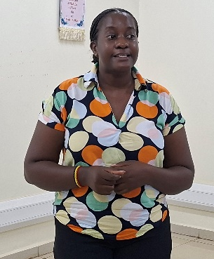
Figure 1Angela Kisakye [photo by Bond]
This participatory approach provides an opportunity to compare technical agrometeorological outputs with observations and experiences from people familiar with local seasonal patterns. Such validation is important in improving the accuracy, relevance and usability of climate information intended for farmers and other agricultural stakeholders.
The workshop forms part of UCSATP's efforts to strengthen the generation and dissemination of climate information and early warning services for Uganda's agricultural sector. Reliable and locally relevant agrometeorological information can help farmers and other value-chain actors make better decisions on activities such as land preparation, planting, crop management and harvesting.
The validation of seasonal information is particularly important in the context of increasing climate variability, which continues to make agricultural planning more difficult. Strengthening the link between scientific climate information and local knowledge can improve the usefulness of early warning products and support more timely responses to climate-related risks.
Through the workshop, the Agrometeorology Team is therefore seeking to refine its outputs before they are used more widely to inform agricultural advisories and other climate services under UCSATP.
The exercise at NARL Kawanda represents an important step towards developing climate information that is not only scientifically sound, but also reflects the realities experienced by farmers and communities across Uganda.

