Agrometeorology Unit Begins Analysis of Agro-Climatic Information for Early Warning Survey Data
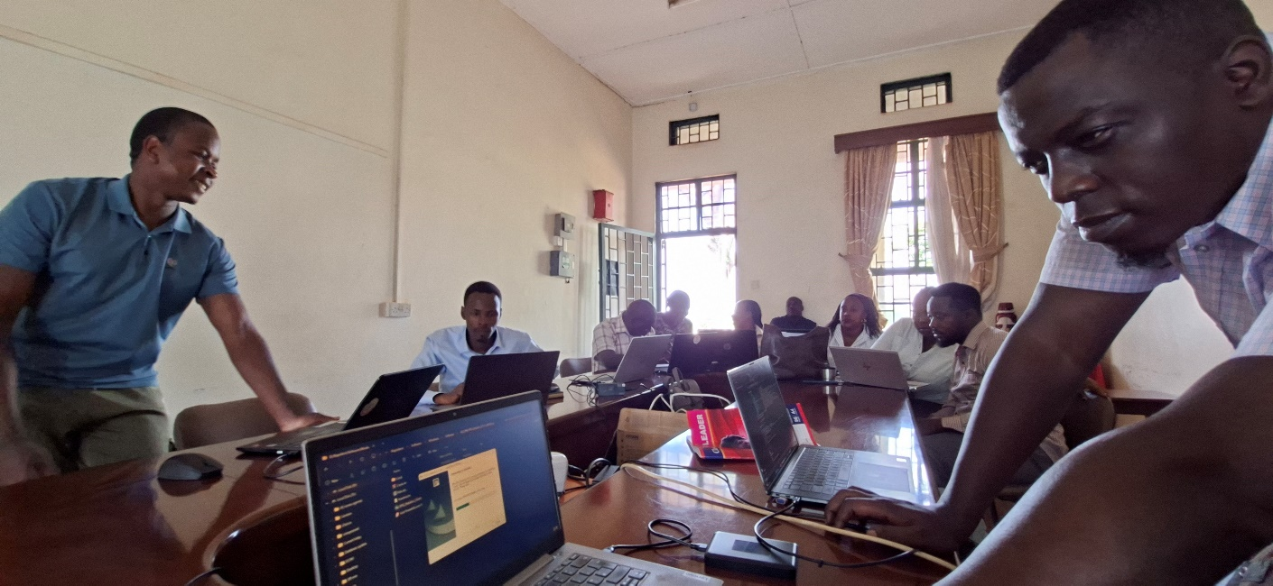
by Bond Matsiko
Kawanda, Uganda | 3 September 2026
The Agrometeorology Unit at the National Agricultural Research Laboratories (NARL), Kawanda, has begun analysing data collected during the recently concluded Agro-Climatic Information for Early Warning Survey, implemented as part of the Uganda Climate-Smart Agricultural Transformation Project (UCSATP).

The exercise, which got underway today, marks the start of a critical processing phase in which raw field data will be examined, cleaned and interpreted to generate agro-climatic information that can feed directly into Uganda's early warning systems for farmers.

The survey forms part of UCSATP's broader effort to strengthen the delivery of climate and agro-meteorological information to farming communities across the country's agroecological zones. Its overall objective is to build Uganda's resilience to climate change by establishing a robust, farmer-facing early warning system that enables timely, evidence-based decisions on planting, input use and other farming activities.

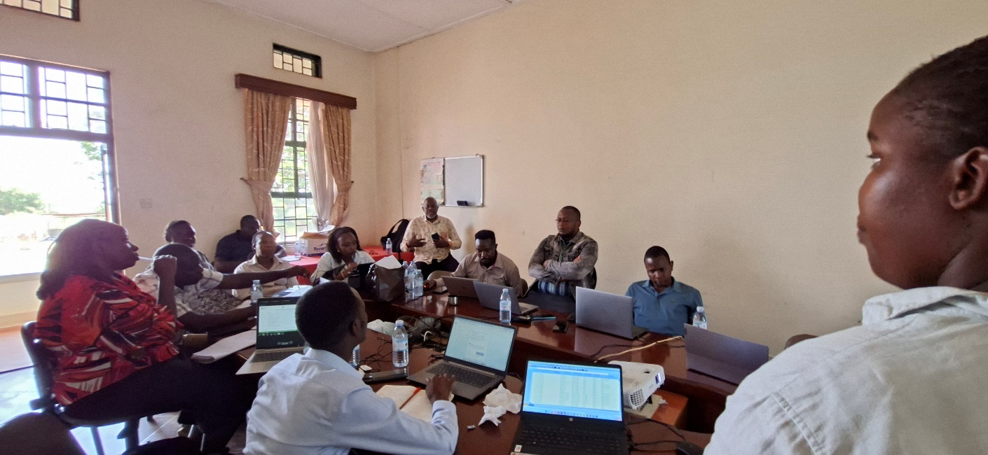
The Agrometeorology Unit, which operates under NARL's Soils, Environment and Agrometeorology programme and is headed by Dr Evelyn Komutunga, with support from Dr. Harron Sseguya, the Chief of Party, is leading the analysis. The unit has been at the centre of NARL's climate information work under UCSATP, including recent efforts to validate seasonal forecasts and strengthen the scientific grounding of early warning products disseminated to farmers.

By translating survey responses into actionable agro-climatic indicators, the analysis is expected to help researchers better understand how farming communities currently access, interpret and act on weather and climate information — and where gaps remain. The findings will inform improvements to the early warning tools and advisory services that NARL and its partners deliver to smallholder farmers under the project.

NARL says the work reflects its continued commitment to translating scientific research into practical tools that help farmers cope with an increasingly unpredictable climate, in line with its mission to innovate for sustainable agricultural transformation.

Further updates on the survey's findings will be published on this website as the analysis progresses.

*UCSATP is implemented by Uganda's Ministry of Agriculture, Animal Industry and Fisheries in partnership with the National Agricultural Research Organisation (NARO), and supports climate-smart agriculture across 69 districts in 13 agroecological zones.*

