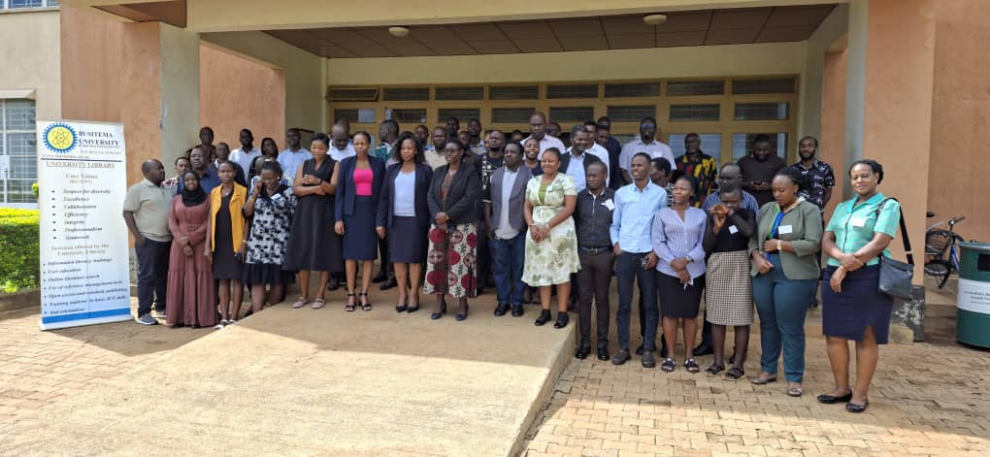NARO and Busitema University to Train Scientists, Data Specialists and Extension Workers in Climate Data Science for Smarter Farming
Busitema University, Uganda: The National Agricultural Research Organisation (NARO) and Busitema University are bringing together scientists, technicians and agricultural extension personnel for a 10-day training programme in climate data science, climate modelling and digital technologies for climate-smart agriculture.
The training will take place at Busitema University's Main Campus [insert dates]. It is hands-on and competency-based, with some sessions possibly held online. Participants will include researchers, data and GIS technicians, and extension workers, along with selected facilitators.

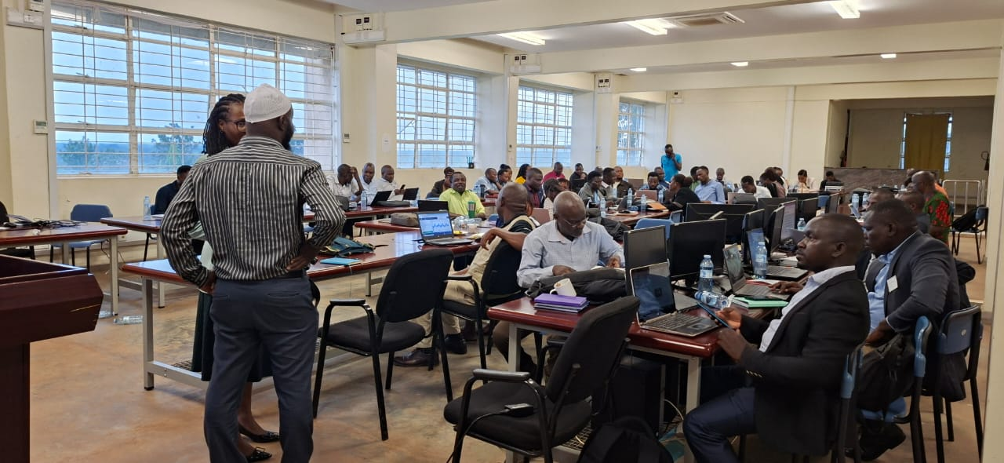From raw data to farm decisions
The programme takes participants step by step from collecting and quality-checking climate and agricultural data through to analysis, modelling, interpretation and communication. The aim is for the results to support real decisions.
Early sessions cover Uganda's climate and agricultural systems, field data collection, climate data sources and statistics. Participants will also learn Python fundamentals, GPS and GIS. Mid-programme topics include climate projections, scenarios and bias correction, remote sensing for crop and drought monitoring, agrometeorology and seasonal analysis, and climate risk and economic analysis.
The later days turn to practical applications: climate-smart agriculture and early-warning frameworks, weather and agricultural information for farm decision-making, machine learning, crop simulation modelling, AI and digital decision-support tools, and a demonstration of an agricultural early-warning system.

Learning by solving real problems
The training does not stop at lectures. From Day 3, participants work in multidisciplinary capstone teams that bring researchers, technicians and extension workers together to tackle real problems. By Day 10, each team is expected to present a tangible decision-support product, such as:
- a risk map
- a climate bulletin
- a prediction model
- an early-warning product
- a farmer advisory
- an integrated analytical report
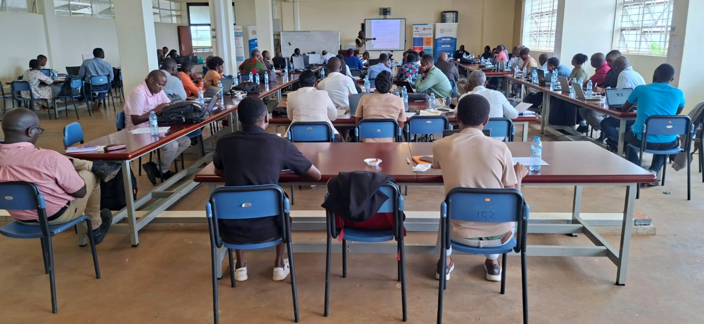A competency assessment and a programme evaluation will follow final presentations. Practical sessions will be tailored to each participant group, and the programme also covers follow-up training and research and innovation opportunities.
The training aims to help Uganda's agricultural institutions turn climate and weather data into timely advice that farmers can act on.

